Goal - to create a robust conversation engine with the least amount of implementation effort. To that end, this document tries to layout some functionality, along with proposed formatting, to give dialog designers the tools necessary to make the conversation feel natural.

*NOTE: We are making many assumptions about the final functionality since we are still developing the hardware*

*I want to make the right arm lift independently to point at the tablet screen and add expressions during conversation. Looking into cost and design issues*

# Responses

At any point in an active conversation we should have the option to trigger one or more of the following responses:

1. *Keyword*
2. *generic IDK (I don’t know)*
3. *confirm*
4. *delay*
5. *repeat*

## Keyword response

When a keyword is detected, the conversation flows to the next point appropriately

## Generic IDK response

Einstein should have several generic “I don’t know what you said, please repeat” responses when no keyword is detected.

User says something Einstein does not understand

Einstein – “Oh no! You caught me daydreaming. Please repeat that.”

User says something else Einstein doesn’t understand

Einstein – “Whoops, my mind was wandering again. Ask again, please?”

User says something else Einstein doesn’t understand

Einstein – “Ok. I confess. I have no idea what you are saying. Perhaps you are the genius and I am the [8 year old boy?]”

## Multiple Keywords response

If multiple keywords are heard, Einstein should ask the user to confirm their response.

Einstein – “What is your favorite color of the rainbow?”

User – “Blue and green.”

Einstein - “If you only had to choose one. Which would it be? Blue or green?”

## Delayed response

If there is a delay of *x* seconds, Einstein should be able to follow up with a reminder phrase.

Einstein – “First, we need to connect to the internet. Are you ready to do that now? Yes or no?”

*\*10s delay*

Einstein – “What do you say, shall we connect to the Internet? Yes or no?”

## Repeat response

If the user wants Einstein to repeat the last phrase, he/she can just use the generic keyword ‘repeat.’ The dialog designer should also be able to create a custom response for the keyword ‘repeat.’

Einstein – “As my new assistant and wunderkind in training, we need fill in your genius profile. A name would be a good start. So, what’s your name?”

User – “Can you repeat that?”

Einstein - “As my new assistant and wunderkind in training, we need fill in your genius profile. A name would be a good start! So, what’s your name?”

-OR-

Einstein - “A name would be a good start. So, what’s your name?”

# TAGs

Specially formatted ‘TAGs’ will be embedded into the body of the script at the point in the dialog where Einstein needs to perform an action, such as: changing his facial expression, pausing for effect, emitting a sfx or changing vocal emotion.

Pause

A Pause tag will cause Einstein to pause for the indicated amount of time (in seconds) before continuing his dialog.

FORMAT: [#’seconds’]

EXAMPLES: [#1.0], [#0.6], [#3.5]

## Expressions

An Expression tag will cause Einstein’s facial expression to change immediately, at the point in the dialog where it appears

FORMAT: <#’expressionID’>

EXAMPLES: <#LA>, <#SU>, <#SK>

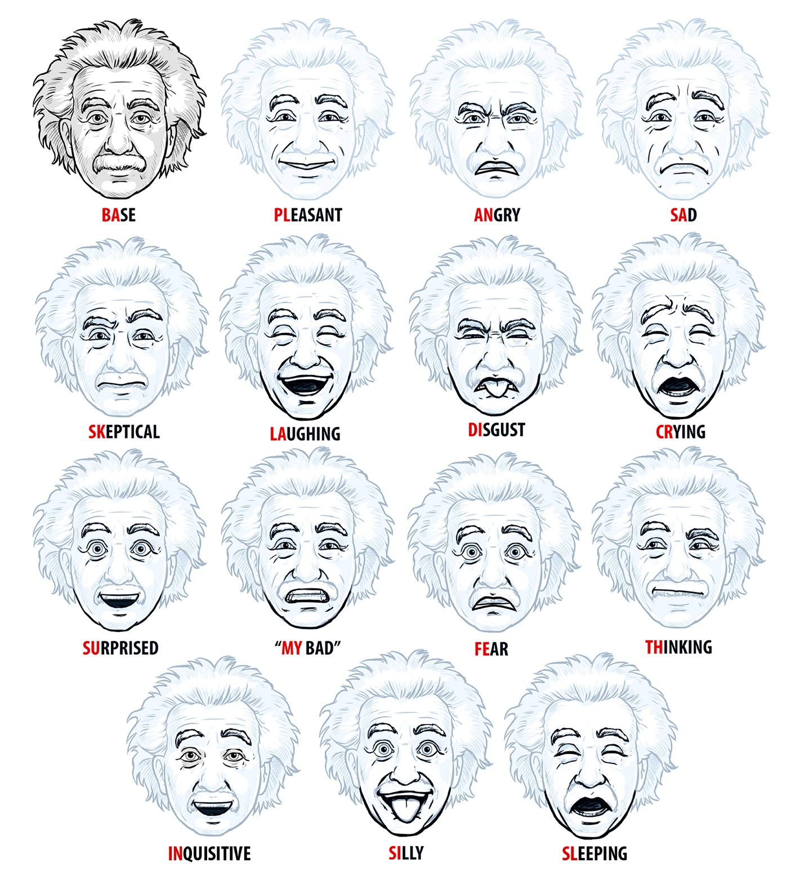

## Emotions

Emotion tags will cause Einstein to change the tone of his vocals to match the emotion. All dialog will default to No special emotion. To switch back to no special emotion from a special emotion just requires the empty tag {}

FORMAT: {’emotionID’}

EXAMPLES: {#HA5}, {#AN2}, {#AP6}

## Profile tags

Profile tags will cause Einstein to dynamically insert the appropriate information from the user’s profile into his dialog at the tag position.

FORMAT: *’profileformatID*

EXAMPLES: *:name*, *:gender*, *:age*

EXAMPLE DIALOG SCRIPT WITH MULTIPLE TAGs

<#SU>Wonderful! [#.5]Now [#.8]<#SU>do exactly as I say or we may disrupt the flow of time and space and bring the universe as we know it to a <#WE> crashing end! [#.5]<#LA>Just kidding! [#.5]<#SK>But seriously, [#1]pay attention.